Wilson Horn

Research by Rebekah Dix

Myopic Best Responding in Spatial Networks: Making Uber Efficient

Through applications such as Uber and Lyft, we now have access to transportation twenty-four seven. How has the rise of ride-sharing apps, breaking away from the taxi tradition, shaped drivers’ choices as they operate within their app’s network? Truthfully, it hasn’t. Currently, those apps don’t allow drivers to see each other as they decide where to locate themselves in high rider-traffic areas despite how other drivers’ choices would affect their own. Rebekah Dix in her paper, “Myopic Best Responding in Spatial Networks,” examine the effect of others’ spatial allocations on a myopic agent’s choice within a given spatial network, arguing myopic best responding leads to greater efficiency.

Dix defines efficient spatial allocation as the average distance between each node and the nearest agent in the spatial network, as average distance decreases efficiency increases. Applied to a ride-sharing context, the expected wait-time for passengers would be inversely proportional to the average distance between passengers and the nearest driver in an area. The researchers were able to model the complex, dynamic environment in which this unfolds as a sequential, static game of an individual agent’s choices. The goal of the players is to maximize the size of their Voronoi diagram, a subset of the entire spatial network which changes in size depending on their distance from other drivers, akin to the territory of passengers a driver is responsible for. The game sought to test the behavioral assumption that agents maximize their current payoff at the time of their choice, myopically best responding, when faced with allocation in dynamic spatial games. An individual’s myopic best response is a move that would maximally increase their Voronoi diagram in the current turn, without accounting for the moves that rival agents may make in the future. In complex games such as this, myopically best responding (MBR) will lead to suboptimal outcomes, but in the face of costs associated with sophisticated strategization, myopically best responding may be rational as a decision-making heuristic, especially in regard to cost.

In the experiment, there are five players whose turn orders are selected randomly. In each trial players started from this distributed allocation

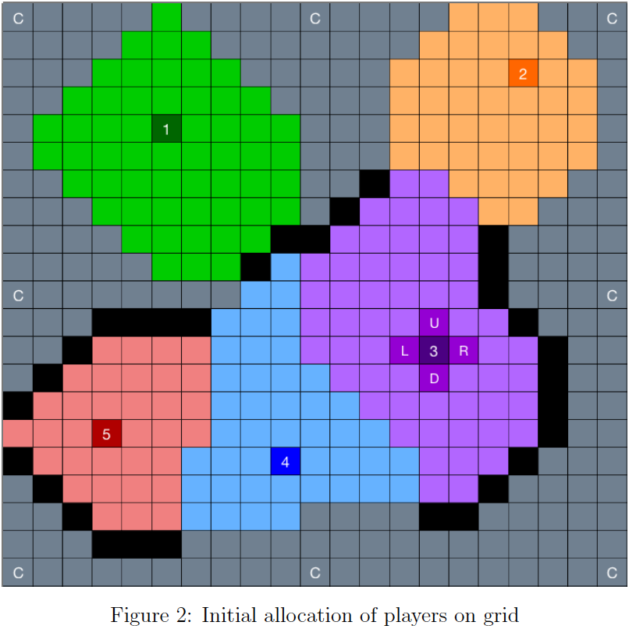

across a 21 x 21 grid. Players were allowed to make a single move during their turn in one of four cardinal directions or to remain in the same location, only restricting movement to an occupied space. Additionally, eight non-moving computer players were positioned along the borders of the grid to model the presence of boundaries. Each player is provided a move calculator that calculates a Voronoi diagram that could account for other players’ moves. This calculator was provided for two reasons: calculating Voronoi diagram area is time-consuming for players and providing observable insights into players’ thought-processes for the experimenters as the game evolves by recording the calculations they made. Turns are limited to two minutes. A move’s flow payment is calculated as the area of the player’s Voronoi region after their move is made. The experimenters rank order available moves, FP1 being the move option with the highest flow payment.

The first result of their research was that players chose the FP1 move 60% of the time, rising to 63% when excluding the first ten minutes of the game. While this could be attributed to the majority of players operating under the MBR assumption, it as likely be indicative of sophisticated consideration of later moves or luck. Upon further examination of player’s calculations who made the FP1 move, very few calculations were made that would suggest higher-order reasoning and most calculations were made on a player’s turn, only evaluating their movement options and opponents’ current static allocation. Another illuminating finding was in 82% of player calculations, opponents were in the same place as the current iteration of the experiment, with 76% of calculations being solely move options. This reveals that most of the time players were not acknowledging potential moves opponents could make in the future, instead focusing on their own move options for the iteration during their turn. Experimenters next found that 92% of calculations made by players were within one space of that player’s current position. This is used as jumping off point to analyze non-FP1 moves and whether those moves were suggestive of higher-order reasoning on opponent choices. Parsing moves players have made into an interval of all moves made between a player’s current turn and previous turn reveals when the FP1 move was not chosen. It was often not calculated, more indicative of a failure to consider this move rather than higher-order thinking.

The researchers further partitioned non-FP1 moves into two different types, Highest Scoring Calculated Move (HSCM) and Suggestive of Higher-order Reasoning (SHO). The HSCM is a move in which the player did not calculate the FP1 move, instead choosing the highest scoring option of those they calculated as their move. On the other hand, SHO moves refer to those players that calculated the FP1 move and the move chosen, this is suggestive of Higher-order Reasoning because it reveals that despite knowing their best move they chose otherwise which could imply other strategic considerations were at play when they opted against the FP1 move. Player behavior when selecting the HSCM supports the myopic best responding assumption, choosing the best move they could for those they thought of. Of the 307 SHO moves (2178 total moves) players were correctly using the calculator when not selecting the FP1 move. Interestingly, 24% of all SHO moves were selected by less than 7% of players which was interpreted as an intuitive move by the players when flow payments between moves were close. When comparing average flow payment differences between SHO and FP1 moves (.82 grid squares) versus that of non-SHO, non-FP1 moves and their FP1 alternative (1.74 grid squares) the former was found to be significantly smaller than the latter, further supporting the thought that players rely on intuition and higher-order reasoning when evaluating similar flow payments. Despite indications of wider considerations in SHO moves there was not a significant relationship between number of SHO moves and session scores although number of FP1 moves and session score were found to have a significant positive relationship. Clearly FP1 moves were the best move set, but researchers found that the closer players adhered to the MBR assumption, the better they performed within the experiment, given that they only played against similar players and not against sophisticated agents. Although this experiment does not definitively prove players myopically best respond, there is no significant evidence providing support that players violate the MBR assumption.

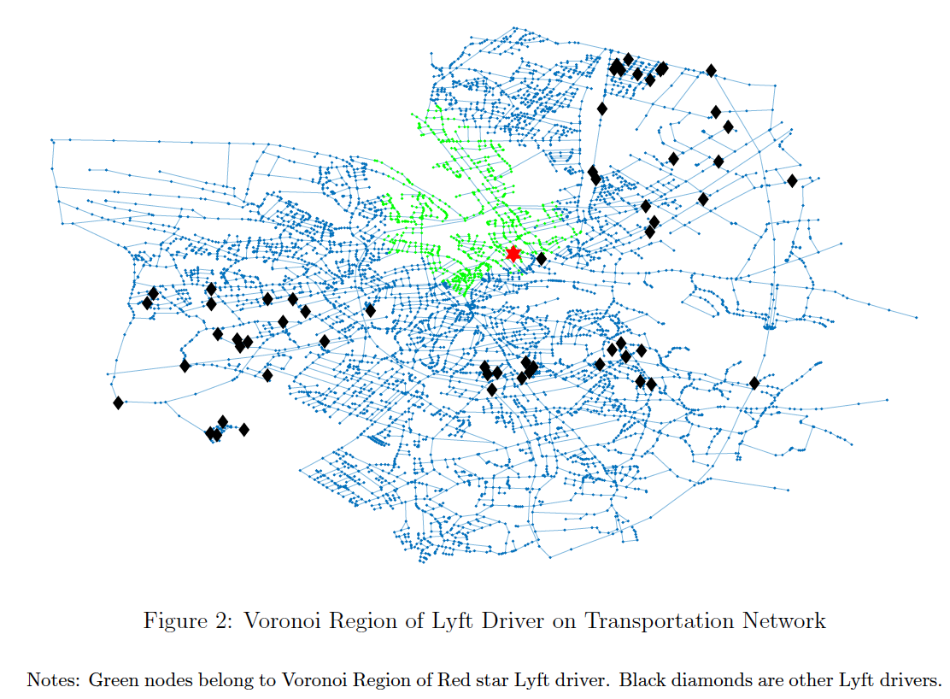

In application, myopically best responding is perhaps the most useful avenue of choice given the low stakes in ride-sharing apps and the high cost relative to benefit of reasoning at a higher level. To evaluate the efficacy of myopic best responding, researchers tested MBR behavior in a transportation network model built from a real-life city. First reconstructing the transportation network of the German city of Oldenburg as a spatial network, then creating an Agent-Based Model of myopic best response trained on the data collected from the games previously played by participants were able to reduce spatial inefficiency within the model from 2.02 in the initial allocation to .55 in the final allocation, after 5,000 iterations. Although nearly a 75% reduction in inefficiency, it does not converge to an optimal allocation mainly due to a barrier called boundary behavior. Boundary behavior is the interaction of opposing incentives to move inward in the network to increase market share while not going so far as to lose the area around the boundary of the network. Addressing this, researchers fixed 14 of the 60 model drivers around the network periphery decreasing spatial inefficiency from .34 initially to .2 in the final allocation after 3,000 iterations. This allowed for MBR behavior in the center to continue yet reducing boundary behavior, further increasing efficiency.

In sum, within an experimental setting players myopically best responding may not be choosing the strictly best move option but this method of heuristic decision-making is best when accounting for the small marginal benefit between MBR and FP1 choices and the cost of sophisticated reasoning. This behavior, modeled within real spatial models, decreases inefficiency particularly when planting riders along the network periphery. Given the low stakes game of ride-sharing, a strategy that works well most of the time is better than calculating the strictly best option when incurring its related costs in this context.

As autonomous vehicle technology continues to improve it is not a stretch to say self-driving cars could be in commercial production within the next decade. Investments in Uber’s driverless car technology are substantial and look to increase in coming years. To make the best use of these cars they should position driverless cars along the boundaries in regions where rider demand is not uniformly allocated, this would allow the human drivers to remain in high rider-traffic areas increasing individual pay while also decreasing inefficiency in their ride-sharing system.

Given high worker turnover rates in ride-sharing labor markets it is important that new drivers can acclimate to strategies of efficient allocation. As worker pay is driven in part by quantity of rides given, it is important that new drivers can allocate themselves to high ride-seeking areas to maximize their income. When researchers excluded the first ten minutes of the game the number of FP1 moves made by players rose to 60% to 63% which has implications for driver retention rates. In a short amount of time players began to choose the FP1 option more often which could come as a result of learning and applying the MBR decision-making heuristic. If drivers can adopt MBR behavior sooner, they will begin to make more money in less time than they had anticipated and be more content with their job than had they started their new job less lucratively.

Similar to ride-sharing, emergency transport services and food trucks face similar problems of spatial allocation. Transport services often make trips between hospitals and retirements homes but are also responsible for transporting other people in need of medical attention. Although it may seem intuitive to wait around retirement homes for an emergency call given their relative frequency compared to other location, the choice of many ambulances to act similarly has an implicit cost to others who need to get to the hospital. By allocating themselves near each other, they would leave the person who was in an automobile accident on the highway waiting longer for help than if ambulances were uniformly distributed around the region. Alternatively, food trucks want to allocate themselves in dense areas of people to capture as much of the local market share as possible while avoiding other food trucks that could steal potential customers away. There may be some benefit to grouping in a location where people will know to go for different cuisines, but with too chefs in the proverbial kitchen the quantity of trucks will reach a prohibitive level where it will no longer be profitable to be near other food carts. In both cases, there is an incentive for multiple agents to allocate to the same area, but if too many agents do this it results in a Tragedy of the Commons. With knowledge of the location of competing agents ride-sharing drivers, emergency transport services, and food trucks are a few of the many industries that could benefit from adopting a myopic best response in spatial competition.